**EXPERIMENT NO:2**

Name:R.Vaishnavi

Regno:192224226

1.Alter the table STUDENT with following structure.

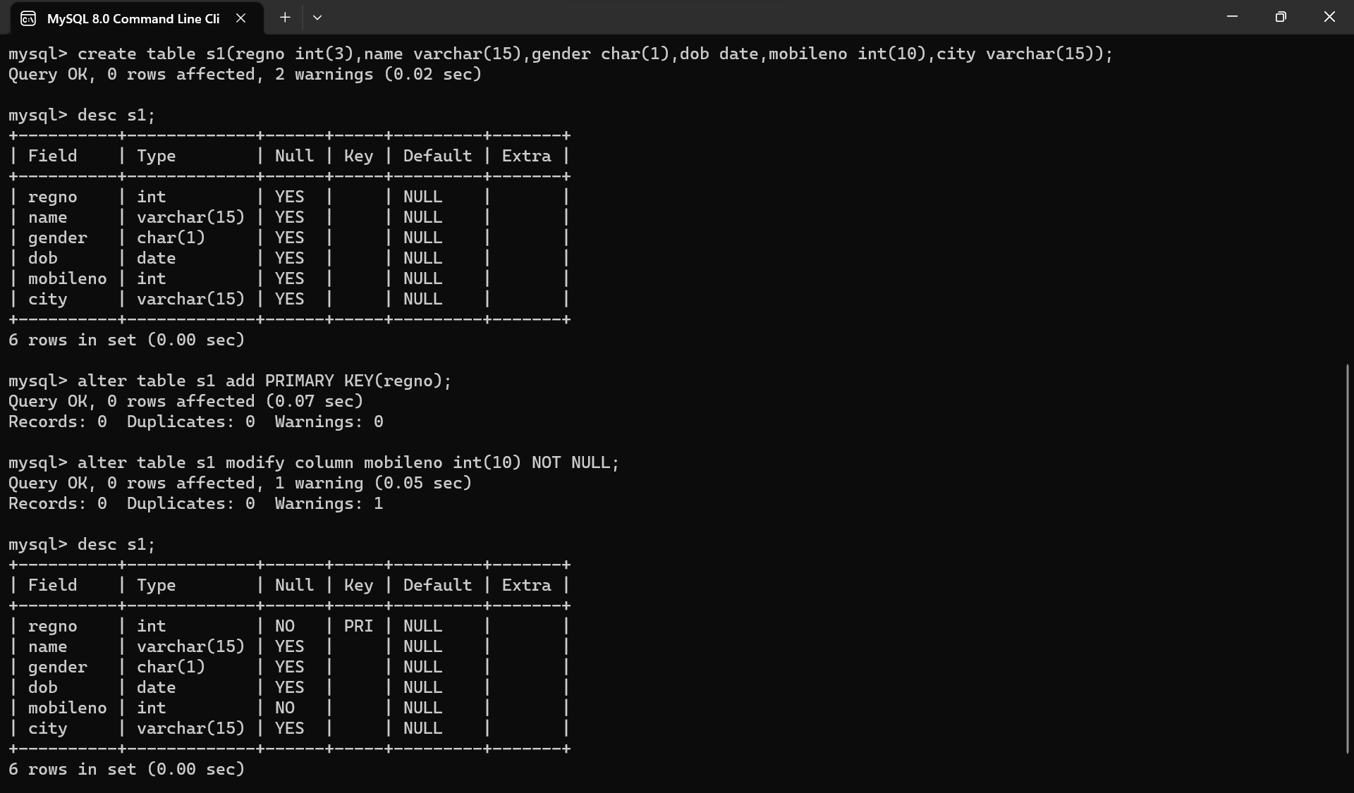

2.Alter the table name FACULTY with following structure.The Deptno in this table refers the Deptno in the DEPARTMENT table.

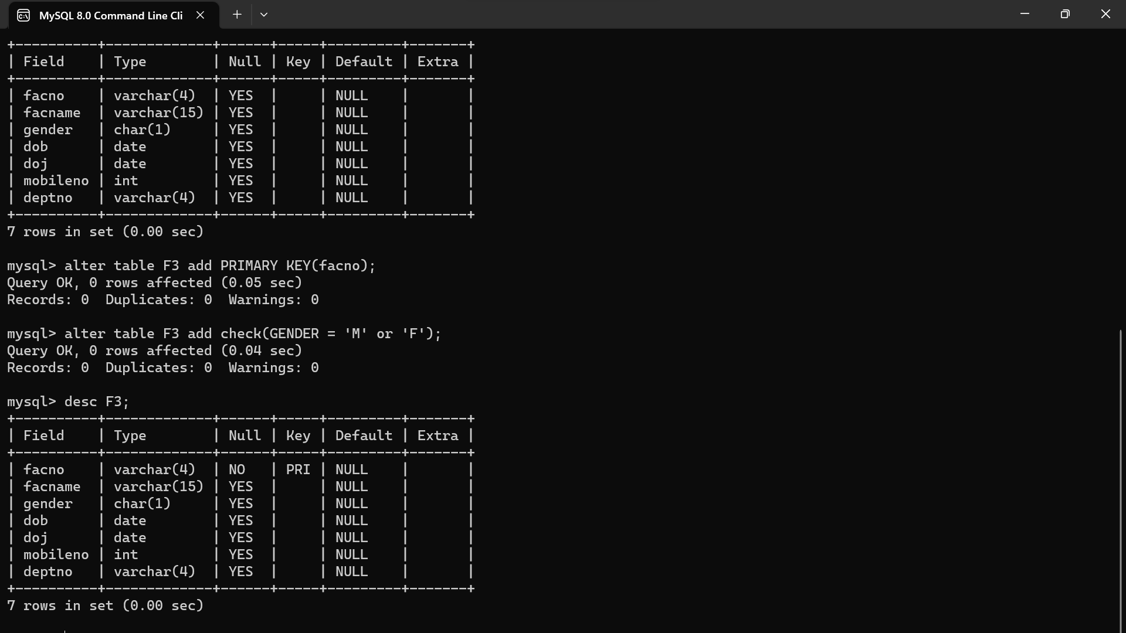

4.Alter the table name DEPARTMENT with following structure.

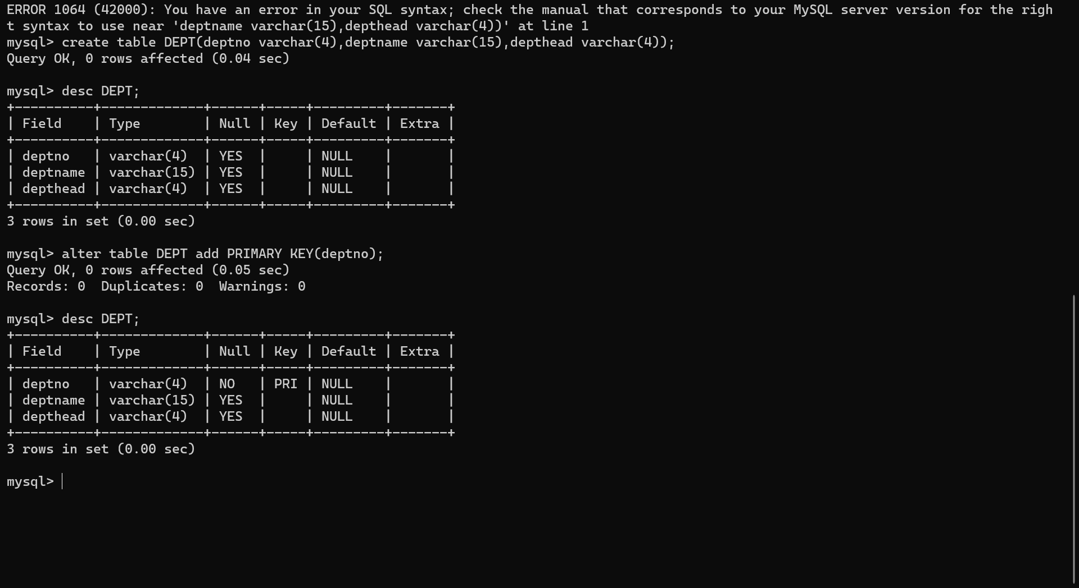

5.Alter the table name COURSES with following structures.

